Title: Bold, Arial 14, Centred

Authors in Times 12, centred, presenting author underlined:

X. Plant¹, Y. Spectra¹, Z. Müller²

Affiliation: Times 10, centred:

¹University of xxx, Institute, Town, Country

¹University of xxx, Institute, Town, Country

Email@boku.ac.at

There must be one blank line between the title, the authors’ names and their affiliation and two blank lines between the affiliation and the beginning of the body text without any punctuation marks at the end of these lines.
All abstracts must be written in English and occupy a maximum of 1 page A4 (including references and Figures). Please make sure to respect the following margins: bottom, right: 2.5 cm; top, left: 3.0 cm.
Body text written in times 12, single line spacing, alignment in mode “justify”.
Reference citations [1] are shown in the text by a number in brackets and follow one double space below the body text under the heading “References” in times 10.
If figures or images are included in the abstract, please insert them as .jpg files.

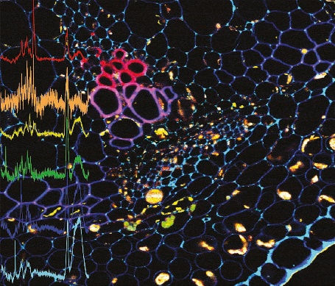

Figure 1: The figure caption is written in Times 10 and aligned with the picture.

References
[1] - The heading “References” follows one double space below the body text in times 10 bold. Reference citations are shown in the text by a numeral in brackets and cited under the heading “References” in times 10.
[2] – P.Noble and B.Collin, J. Polym. Sci. 132, 425 (1975).

Please do not insert text or references in “footnote” mode or other encoding.

